ENERGY CONSERVATION
By Lizzie O

In this pie chart it shows that in Stourbridge we use a lot of gas and electricity, but very little solar power energy. This is because it is quite expensive to have the panels installed on to your house. Most people use gas and electricity as it is automatically available in most houses. So now here are some more facts about energy in Stourbridge.
Solar panel use in Stourbridge PARRY PEOPLE MOVER
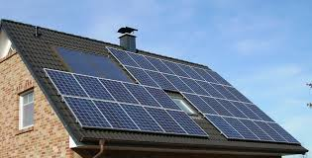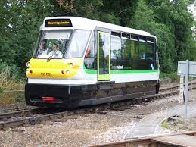
Fitting photovoltaic cells to your property In Stourbridge there is a company
You can have a clean energy supply. It who make a special train that is run with
Also reduces your energy bills. More and very little energy.
more houses in Stourbridge are having
this fitted. I can see 3 from my house
windows. You can get government
grants to help with the cost.
How amazing to create your own energy!
STUDENTS PRODUCE FREE ENERGY

had lots of fun going on a special
‘smoothie bike’. By pedalling very fast you turn a dynamo which produces
electricity. This makes the smoothie
maker work, and you have really nice
drinks. This was a great way
to learn how much energy
is needed to produce
electricity.

FUN FACTS TO SAVE ENERGY
- A heavy coat of dust on a light bulb can block up to half of the light!
- A hot water tap that leaks one drop per second can add up to 165 gallons a month!
- An energy-smart washing machine can save more water in one years than one person drinks in an entire lifetime!
- Every time you open the fridge door, up to 30% of the cold air escapes!

