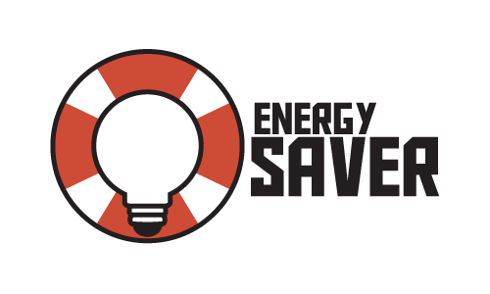
ENERGY
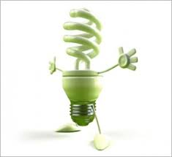
CONSERVATION IN THE
UK
BY FINLEY HANSON AGE 9

What is Energy Conservation?
Conservation means saving or using less energy. If we switch a light off it means we are conserving energy.
Switch off the lights

What is Energy Efficiency?
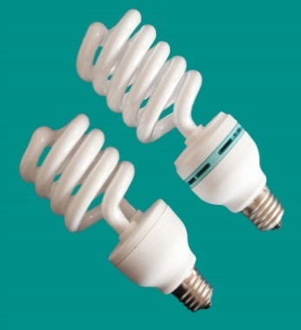
Energy Efficiency also means using less energy, by using products that don’t waste energy.
Energy saving light bulbs.
Why is it important to save energy?
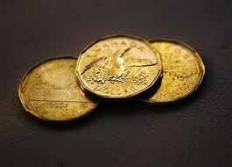
Energy is very expensive. The grown-ups in the house pay for all the electricity you use. So if you waste electricity you waste money!
How can we save energy at home?
It takes a lot of energy to make our homes warm in the winter. If you turn the thermostat down it can make a big difference. If you live in a hot country, use a fan instead of the air conditioning.
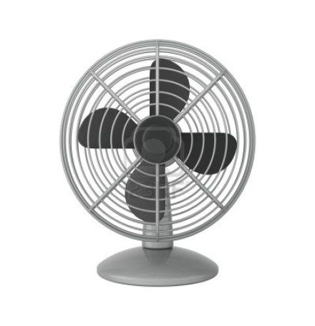
How can you reduce use?
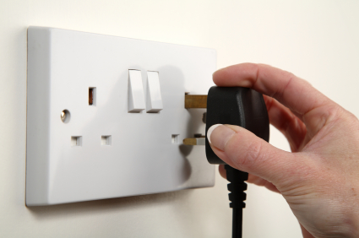
1. Unplug
2 .Turn off the lights
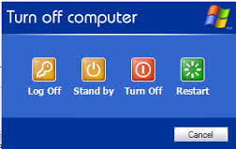
3 .Put computers to sleep
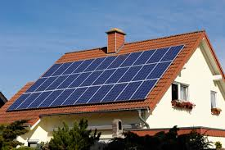
4. Solar panels-make your own energy!

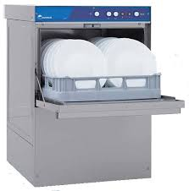
These household items use loads of energy:
A dishwasher
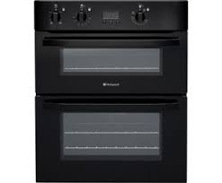
An oven

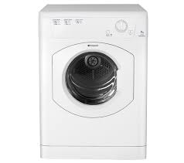
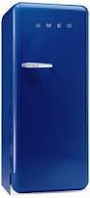
A tumble dryer
A refrigerator

